**OBJECT:** To become familiar with RMI object serialization

**Class Task**

**Api.java**

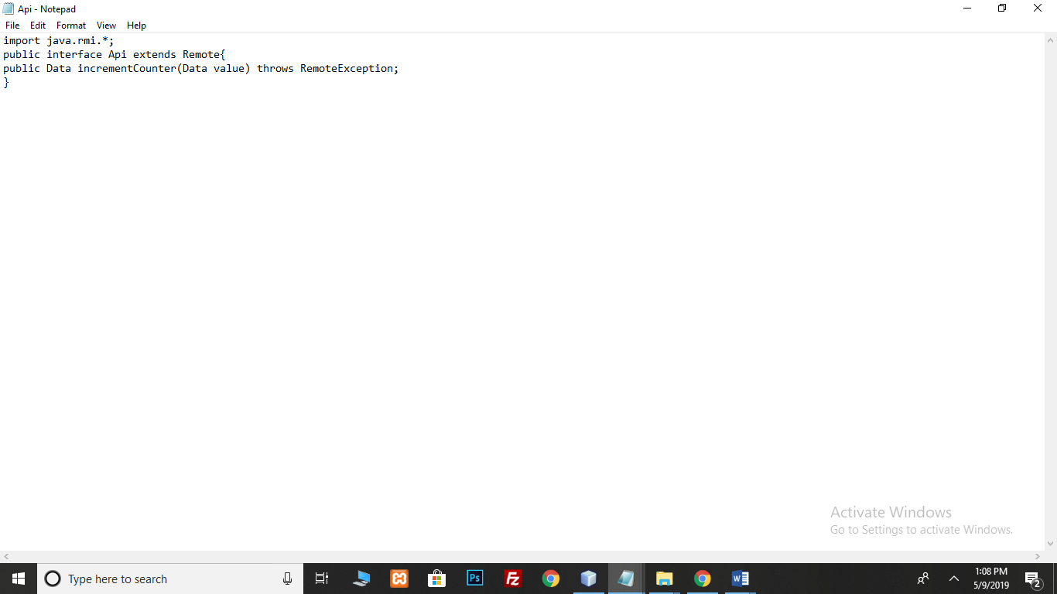

**Data.java**

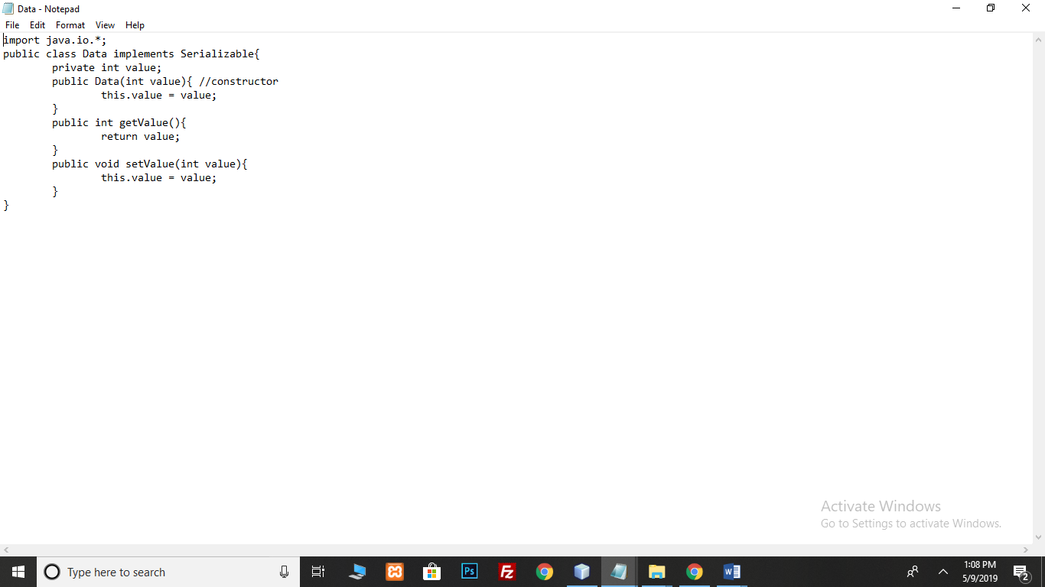

**ApiImpl.java**

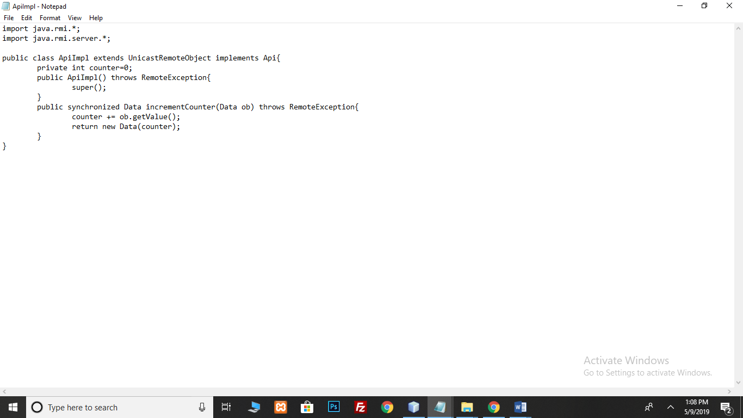

**Server.java**

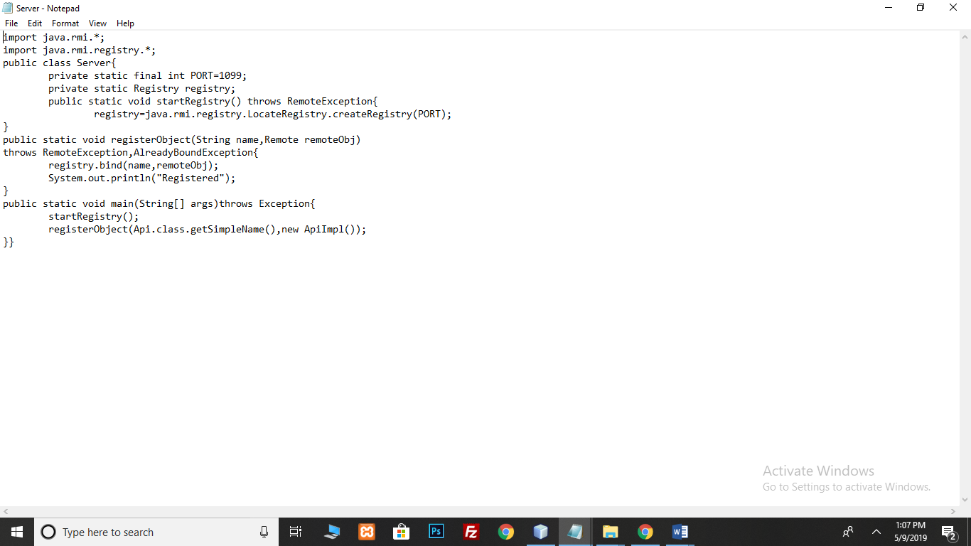

**Client.java**

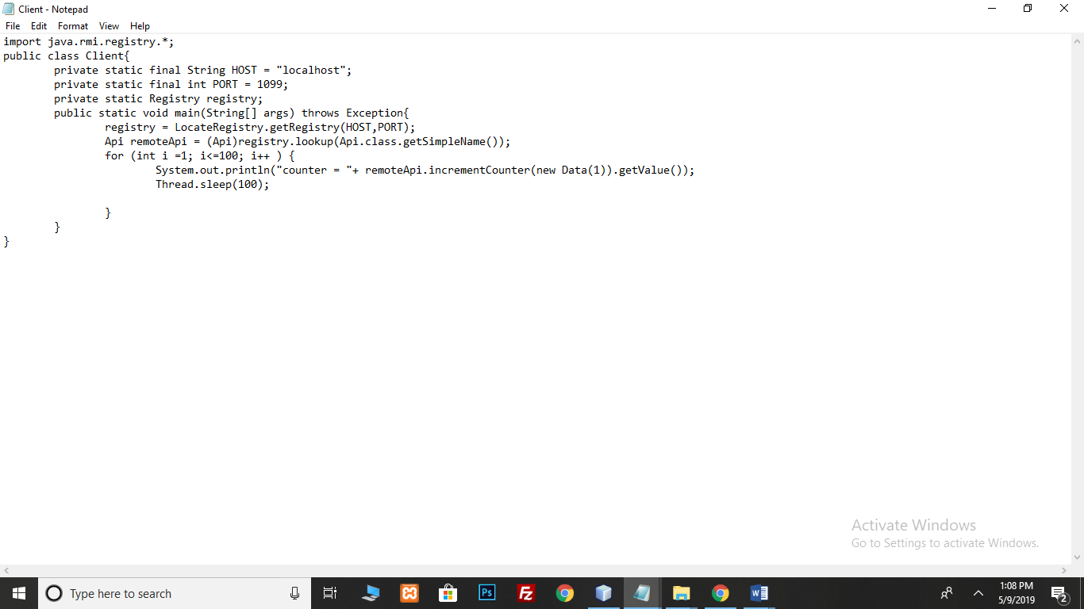

**Output:**

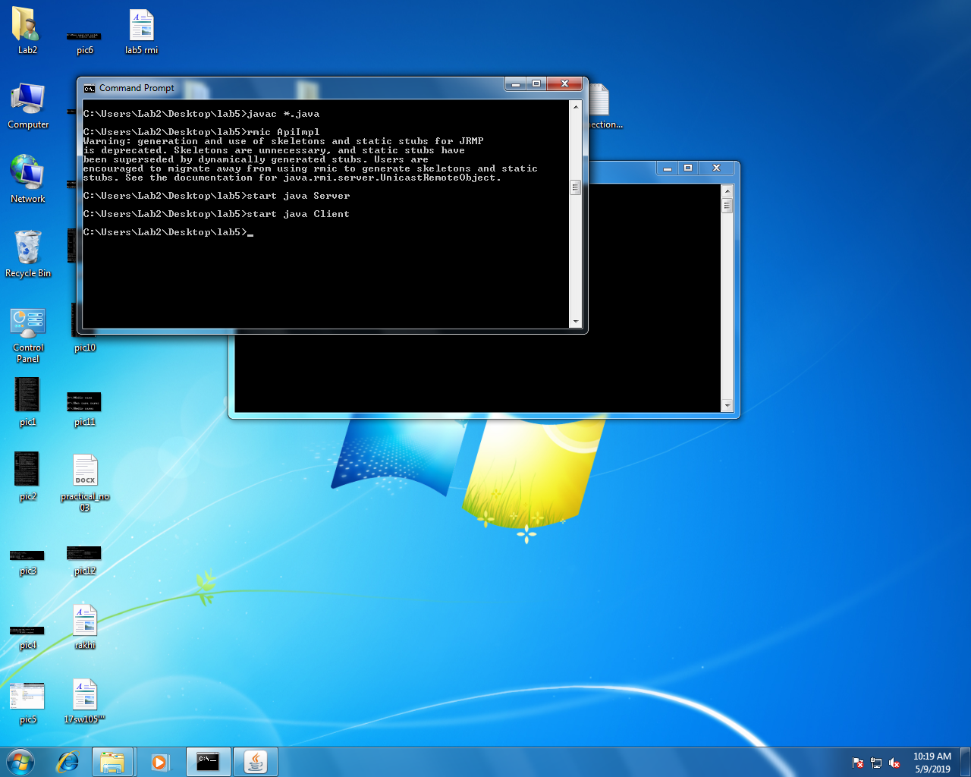

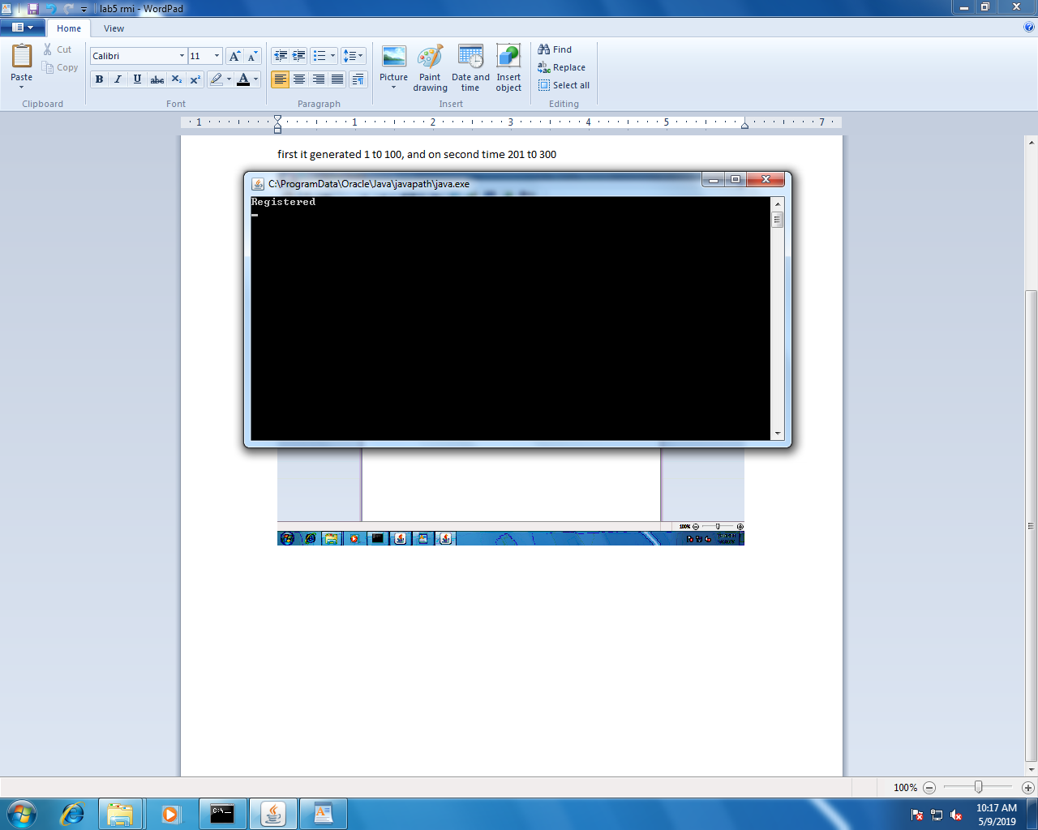

It generates a counter from 1 to 100 at first run then from 200 t0 300 at second and so on.

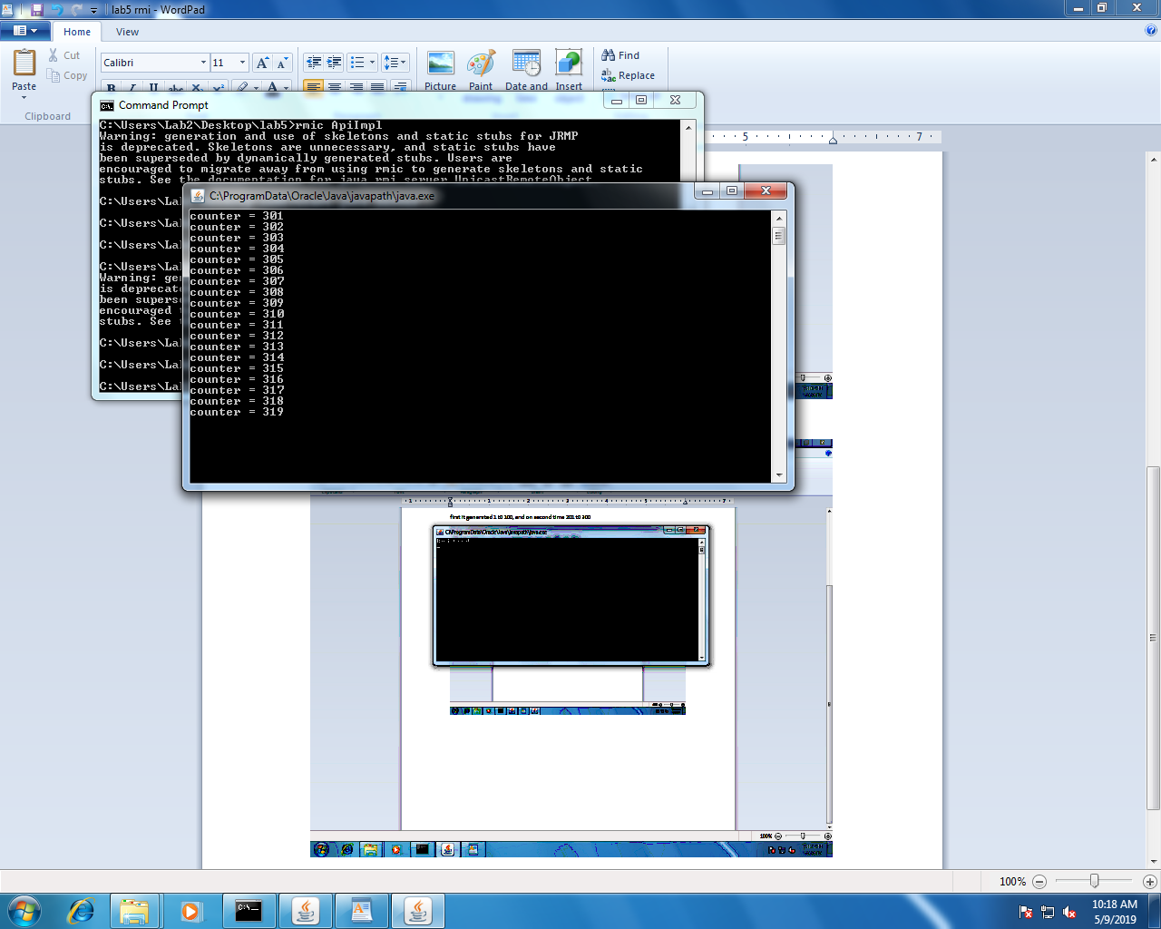

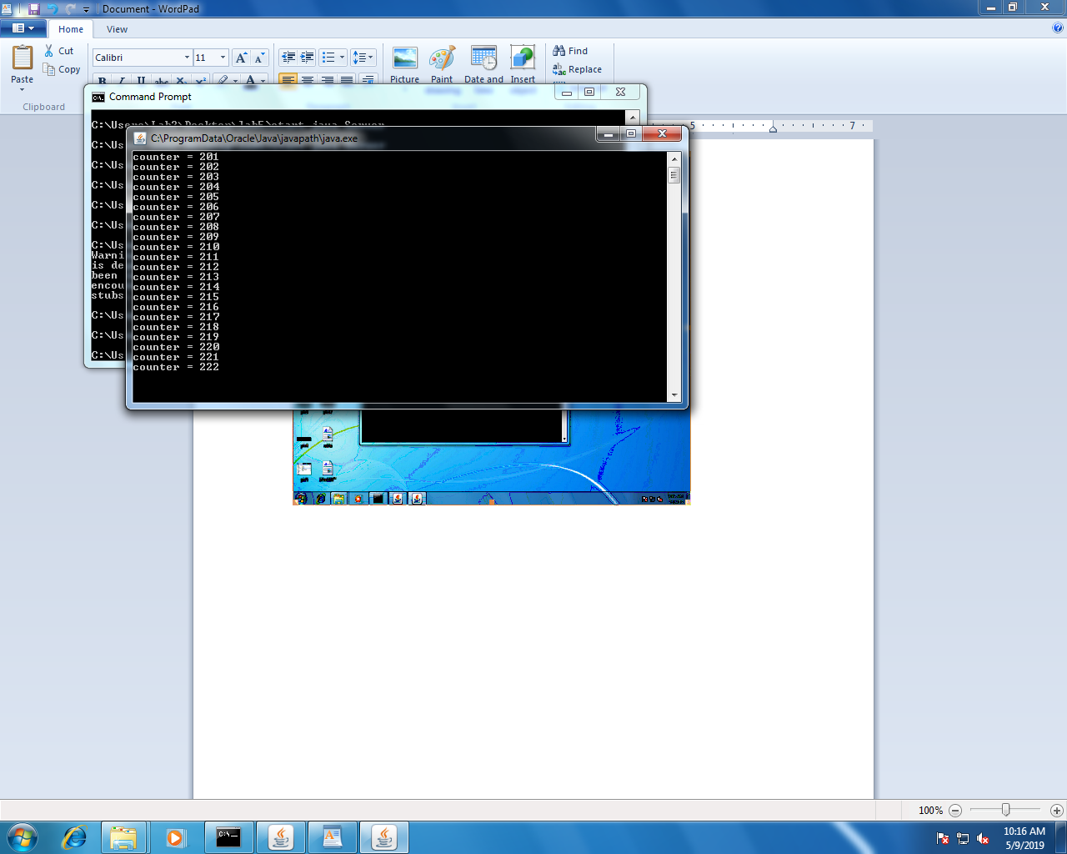

**Lab TASK:**

* **Develop any simple application to demonstrate object passing in RMI. (Expl: Make a class of your own and use its objects as arguments and return types for RMI)**

**Application for generating Even Numbers series and Odd numbers Series**

* **EvenNumber.java**

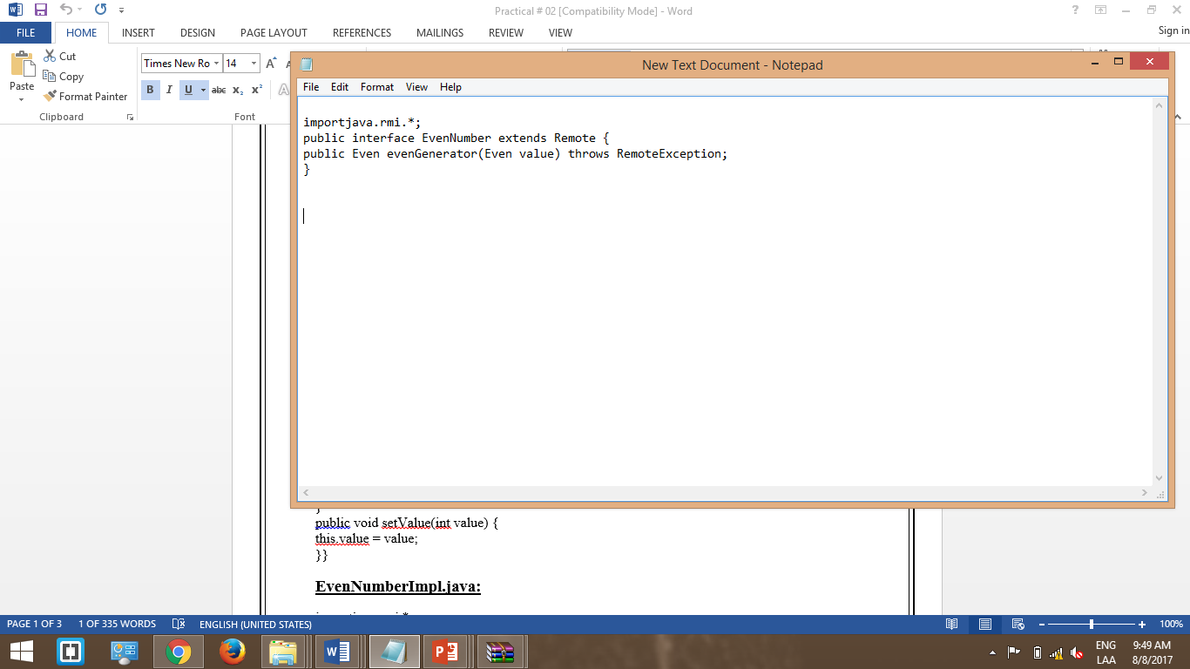

* **Even.java**

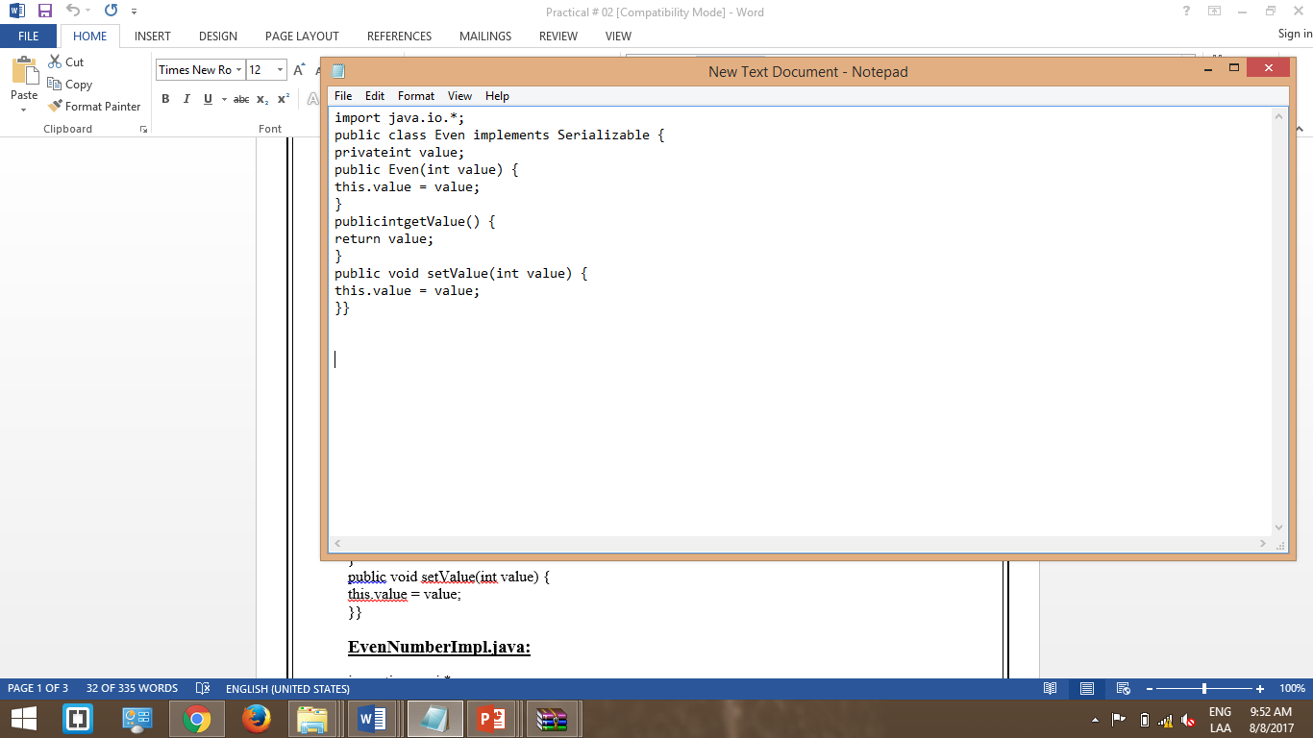

* **EvenNumberImpl.java**

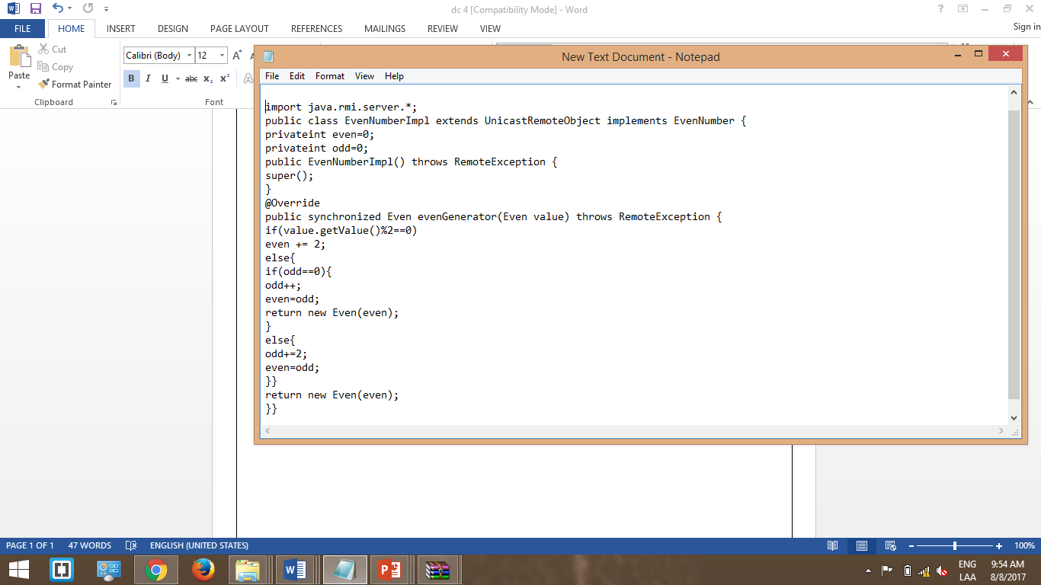

* **EvenServer.java**

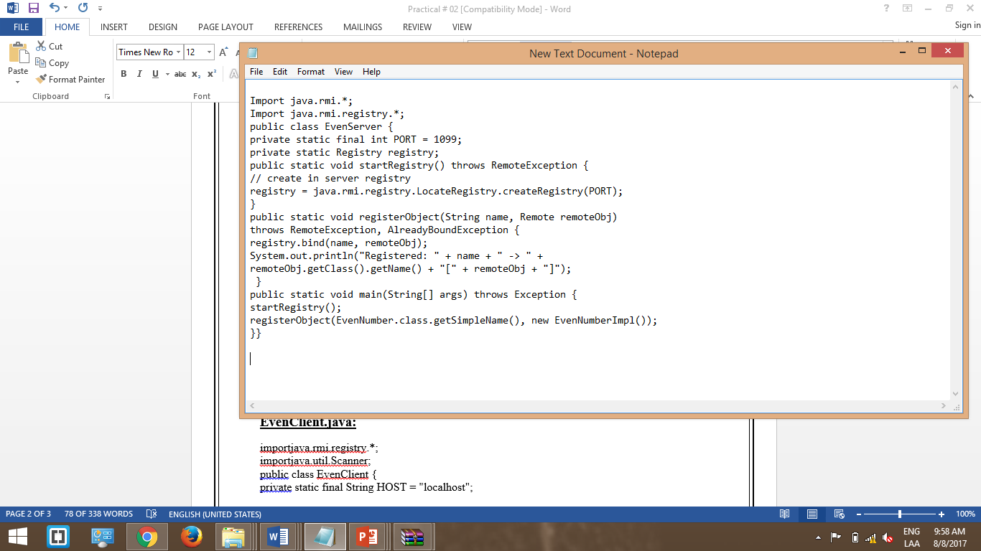

**EvenClient.java**

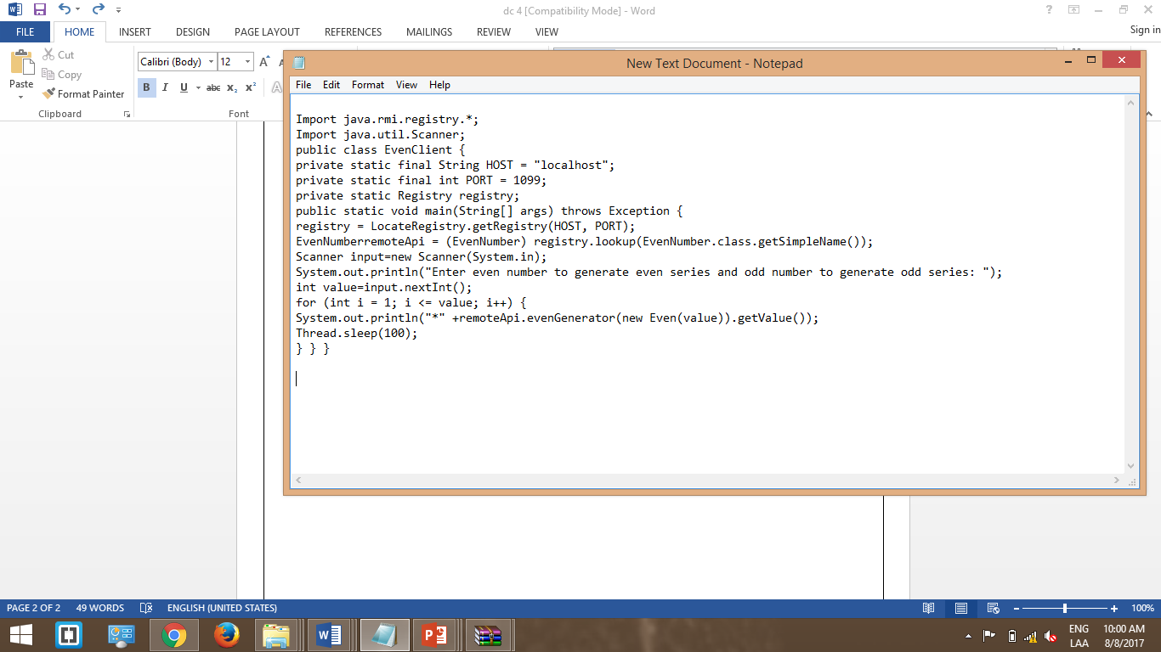

**Output**

